Directions: The goal of the following problems is to help challenge and deepen your understanding of the current topic. Don’t assume that you will know how to answer every question. You will work with at least two other students in the class to try and find solutions and write arguments for each of the following questions. Be sure that you question your classmates’ reasoning. If you don’t understand how they are getting something, you should ASK THEM TO EXPLAIN! Being able to defend your reasoning is important and so you are actually helping them by asking them to explain.

Challenge Questions

- Consider the curve on the interval . Set up integrals with respect to x and y which represent the arc length of the curve on .

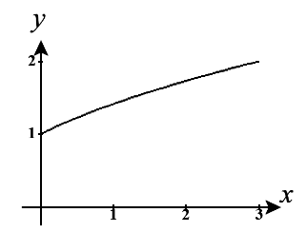

We first note that is continuous on . Therefore, the arc length is given by

We solve our given equation for x.
and we will use this function on the interval .
We note that is continuous on . Therefore, the arc length is given by

- Kyle attempts to find the arc length of on . He sets up the integral , but his professor tells him that there is an issue with his integral and that his integral may not actually represent the length of the curve. What is the problem with Kyle’s work?

The issue here is that is NOT continuous on , specifically at . Therefore, the conditions for the arc length formula are not met and we cannot be certain that the integral represents the length of the curve.

- Consider the curve on the interval .
- Suppose this curve was rotated around the x-axis and the y-axis. Draw pictures of the solids that are created by each of these rotations.
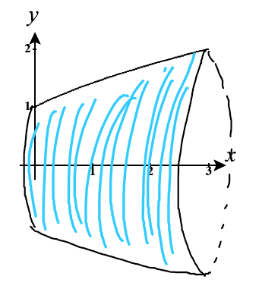

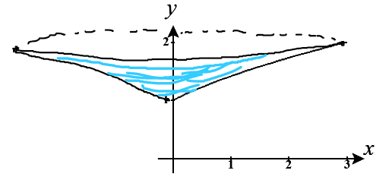

- Consider the case where the curve has been rotated about the x-axis. Setup, but do not evaluate, an integral with respect to x and an integral with respect to y that represent the surface area of the figure.

We first note that is non-negative on and that . Therefore, the surface area is given by

OR

- Consider the case where the curve has been rotated about the y-axis. Setup, but do not evaluate, an integral with respect to x and an integral with respect to y that represent the surface area of the figure.

We first note that is non-negative on and that . Therefore, the surface area is given by

OR

- Consider the curve C given by for .
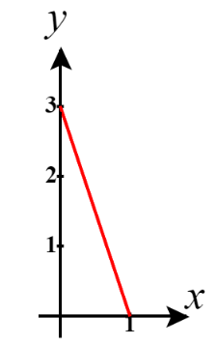
- Sketch the curve and use geometry to compute its length.

We use the distance formula to compute the distance between the endpoints of

- Use integration to compute the length of C.

We see that is continuous on so

- Compute the surface area obtained by rotating the curve C about the x-axis.

We see that is continuous on and y is a non-negative function on so,

- Compute the surface area obtained by rotating the curve C about the y-axis.

Note that and that
We see that is continuous on and x is a non-negative function on so,

- The total surface area of a right cone of height h and radius r (not counting the circular base) is given by . Derive this formula for the surface area of the cone using calculus.

A cone is made when line is revolved around the x-axis. Note here (as seen in the picture below) that the slope of this line is given by and the y-intercept of this line must be through the origin otherwise the resulting shape would not be a full cone. Therefore, the surface area of the cone is given by
- Determine the radius and height of the cones in parts (c) and (d) and then use the formula you created in part (e) to confirm the calculation of the surface area that you found in parts (c) and (d).

We see that the cone obtained by rotating the line for about the x-axis would have a height of 1 and a radius of 3. Therefore, the surface area would given as

The cone obtained by rotating the line for about the y-axis would have a height of 3 and a radius of 1. Therefore, the surface area would given as

We can see that both results from parts (c) and (d) are confirmed.

- For the right values of a and b the line will have an arc length on the intervalthat is equal to the surface area of the solid obtained by rotating about the x-axis on this same interval.
- Confirm that this is true if and .

Clearly has a continuous first derivative and is always positive. Therefore, we calculate that
and

- For any given value of a determine the value of b that makes the given scenario true. That is, find a formula for b in terms of a.

and

In order for these two quantities to be equal it must be the case that

Therefore, if , the arc length and surface area will be the same.
Note that this formula confirms the results that we saw in part (a).

